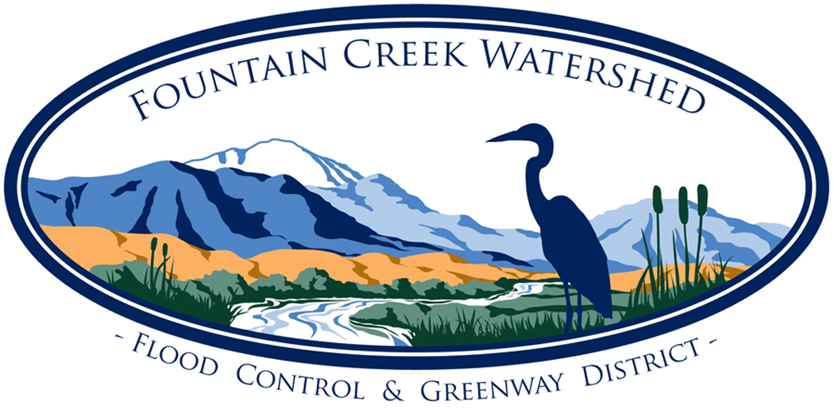
Fountain Creek Watershed, Flood Control and Greenway District
Citizens Advisory Group Meeting Agenda

Friday, February 10, 2023, 9:30 am via Zoom

https://us06web.zoom.us/j/99749871376

(Meetings are open to the public)

- Call to Order, Establish Quorum and Introductions

- Approve Meeting Agenda
- Approve Minutes of Prior Meeting(s)
- January 13, 2023
- Committee Member Comments:
- Public Comments:
- Presentations:
- Reports:
- Governing Board – Alli/Terry
- Projects - Alli
- MMFAC - Alli
- TAC – Laura/Mark/Annie
- Outreach Coordinator/Committee - Susan
- Upcoming activities/events;
- Other jurisdictions
- Website - Mary
- AFCURE – Andra/Annie
- New Business:
- Strategic Planning Discussion
- Topics Calendar for 2023
- Bylaws review
- Old Business:
- Next Meeting: (Future topics: please see list)
- March 10, 2023
11. Adjourn

